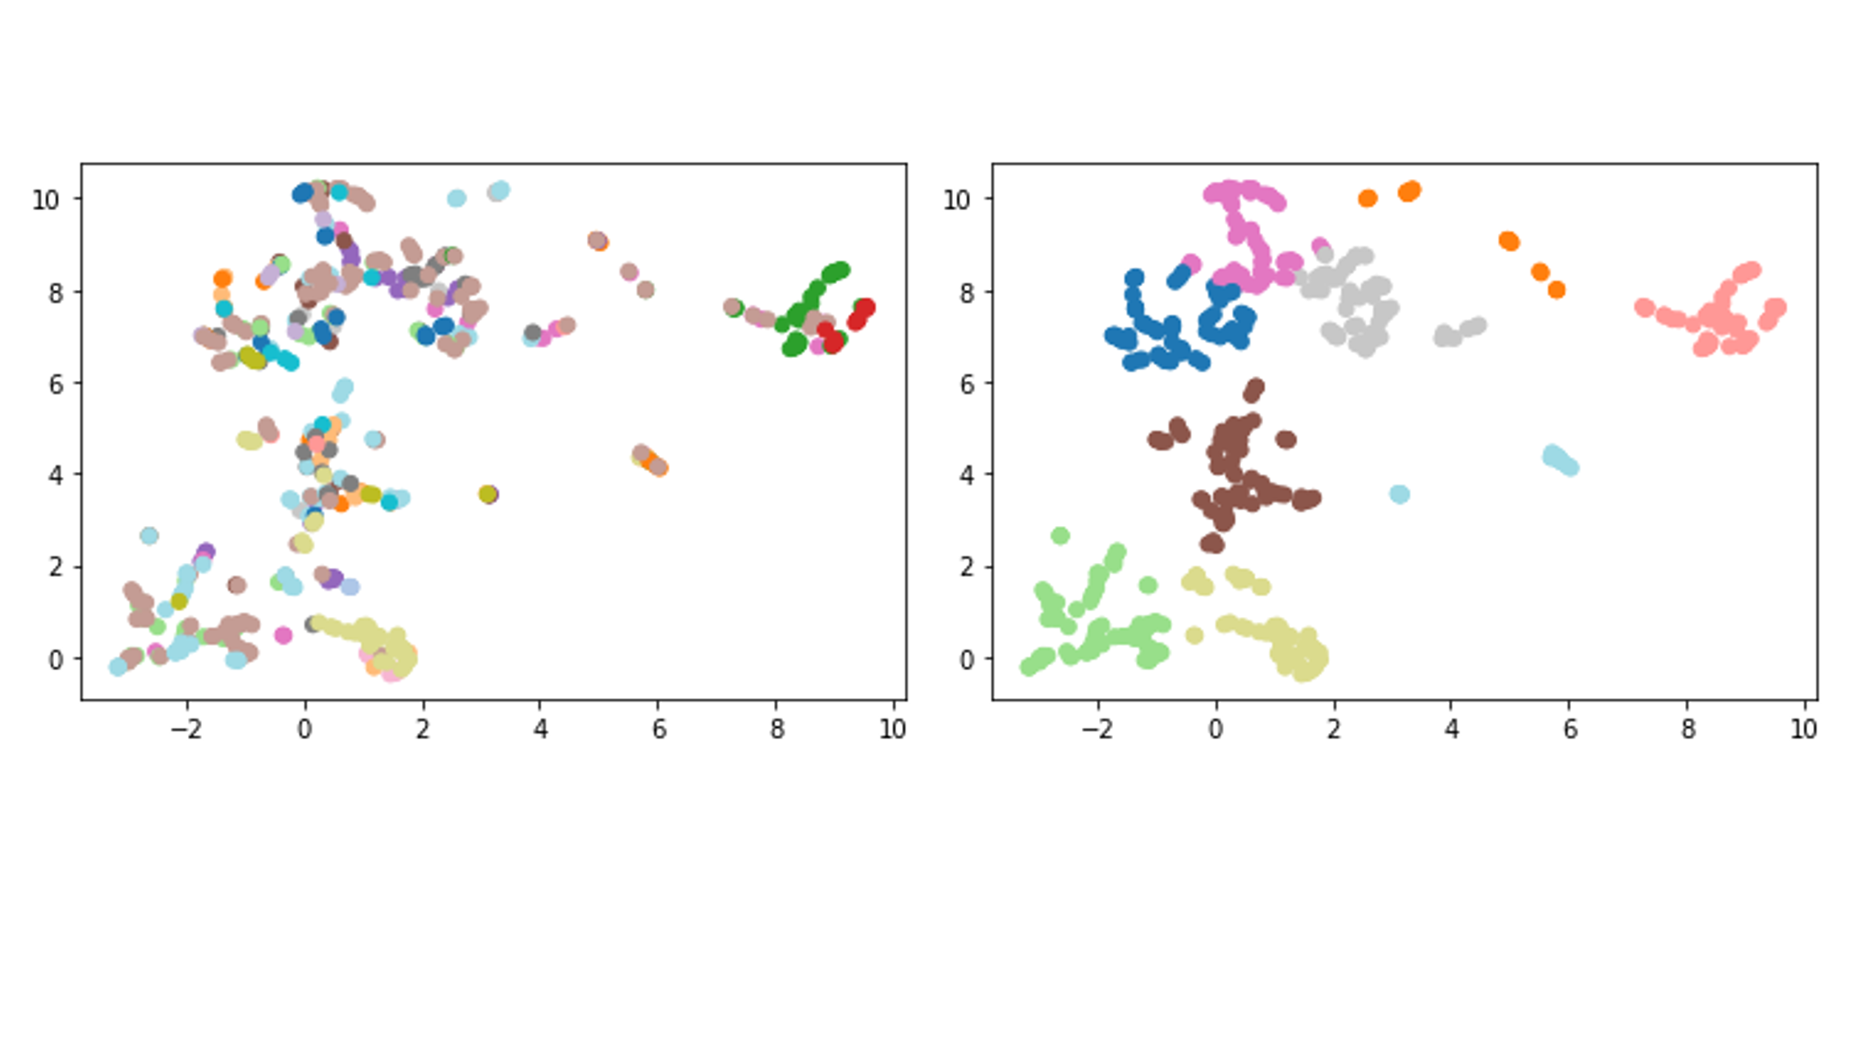

Figure 4. The results of the predictive model illustrate the relatedness of leadership items on larger sample (N = 536)

Notes. Left side illustrates all items with each color representing a different construct. Right side generates the seven prominent clusters produced.